Ta Quang Tung – 104222196

COS20019 – Cloud Computing Architecture - Wk3: ACA Module 11 Guided Lab - Streaming Dynamic Content using Amazon CloudFront

Task 1 – Lab preparation (steps 5-6)

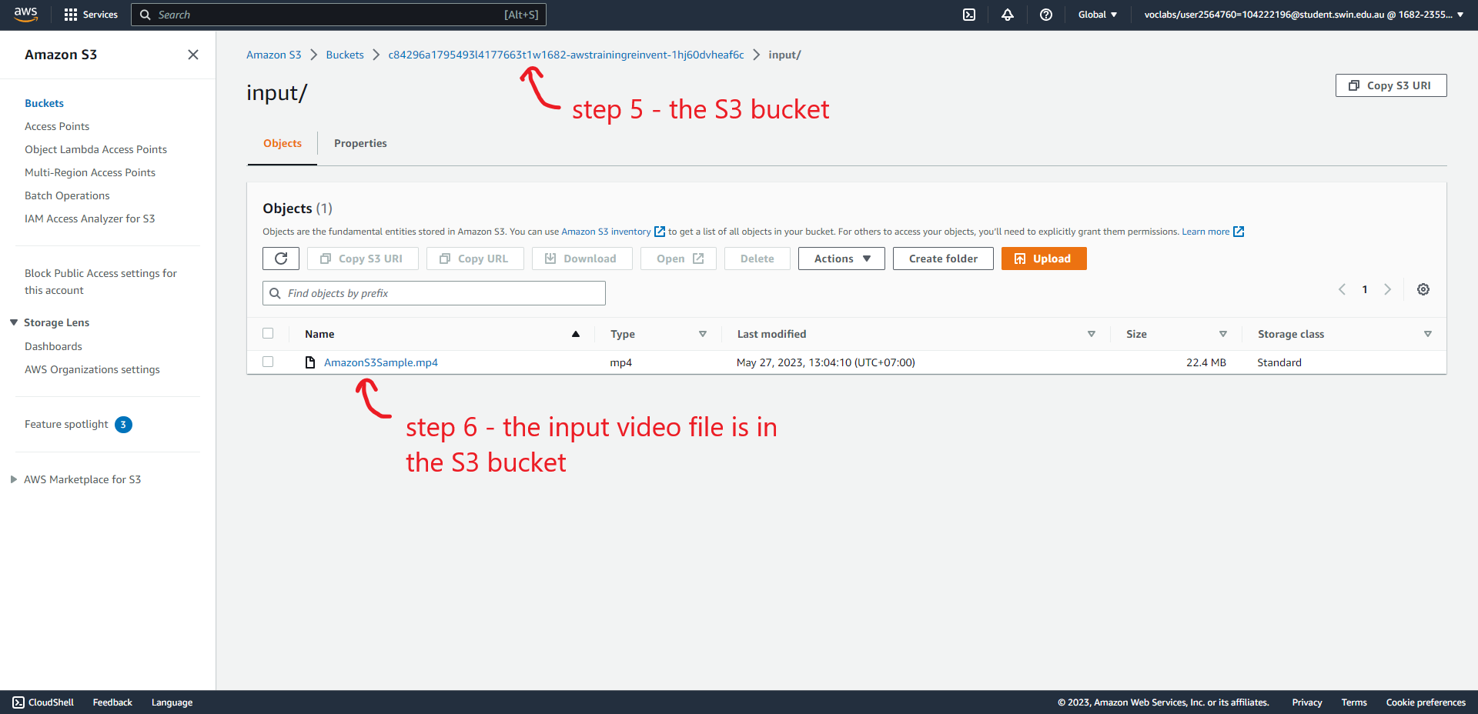

Task 2: Create an Amazon CloudFront Distribution (steps 7-11)

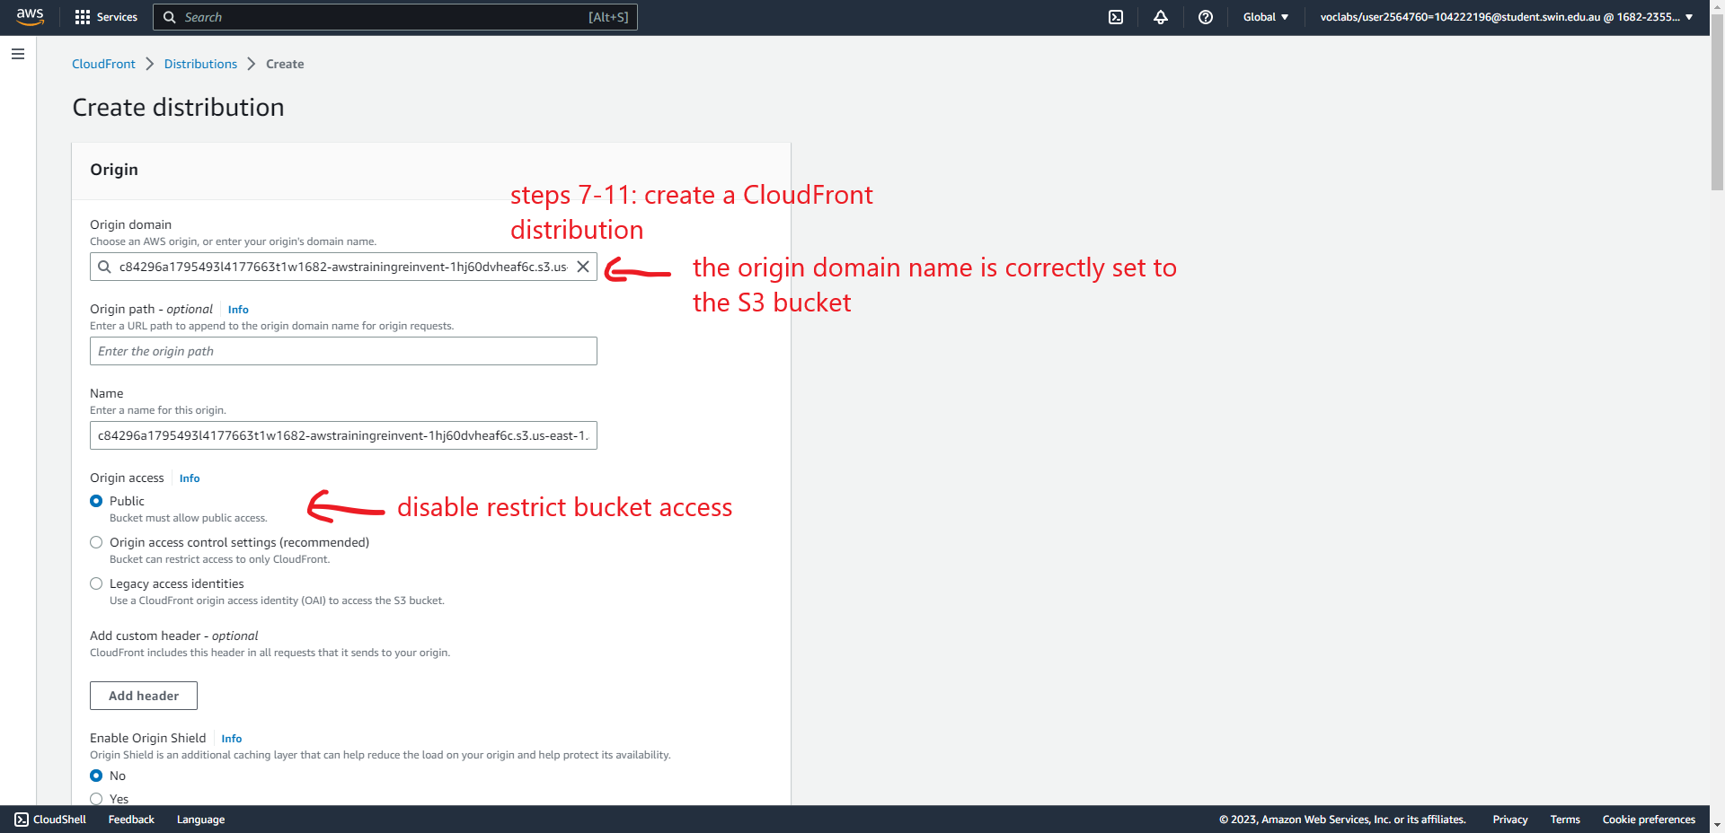

Task 3: Create an Amazon Elastic Transcoder Pipeline (steps 12-31)

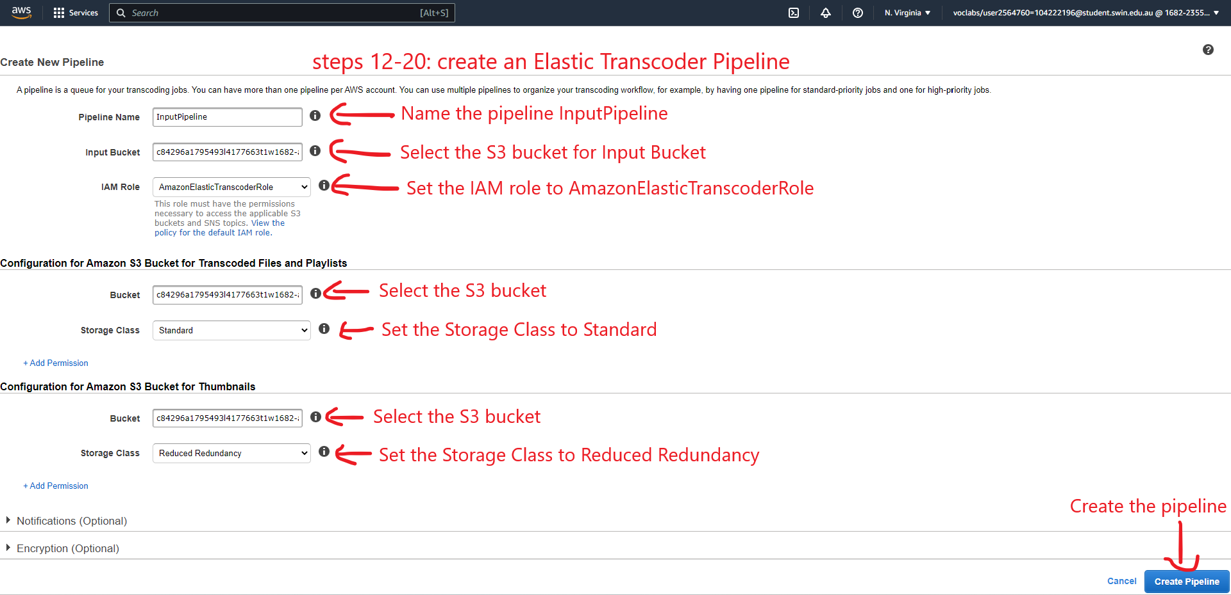

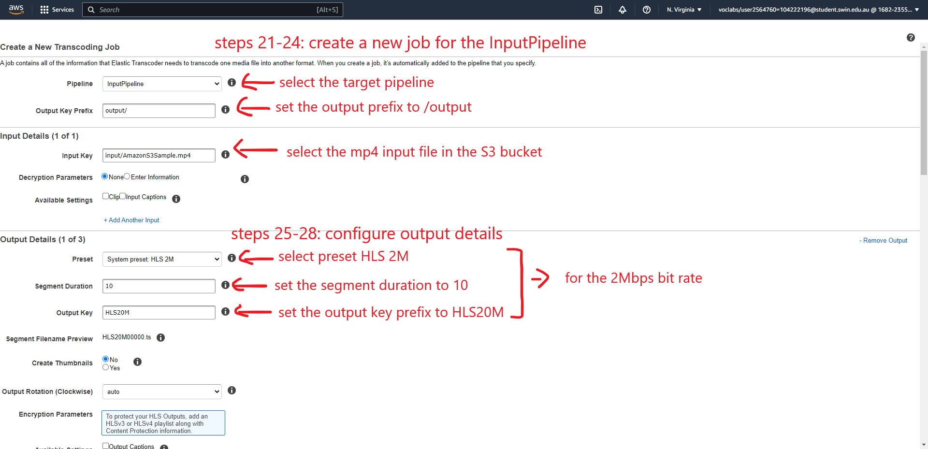

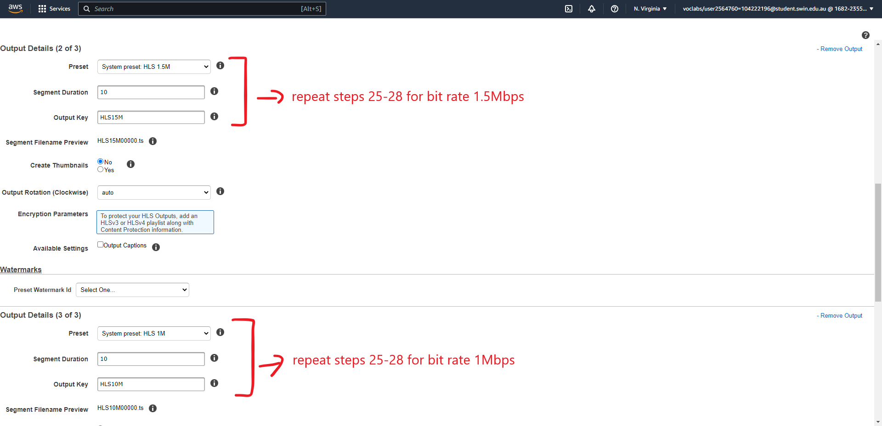

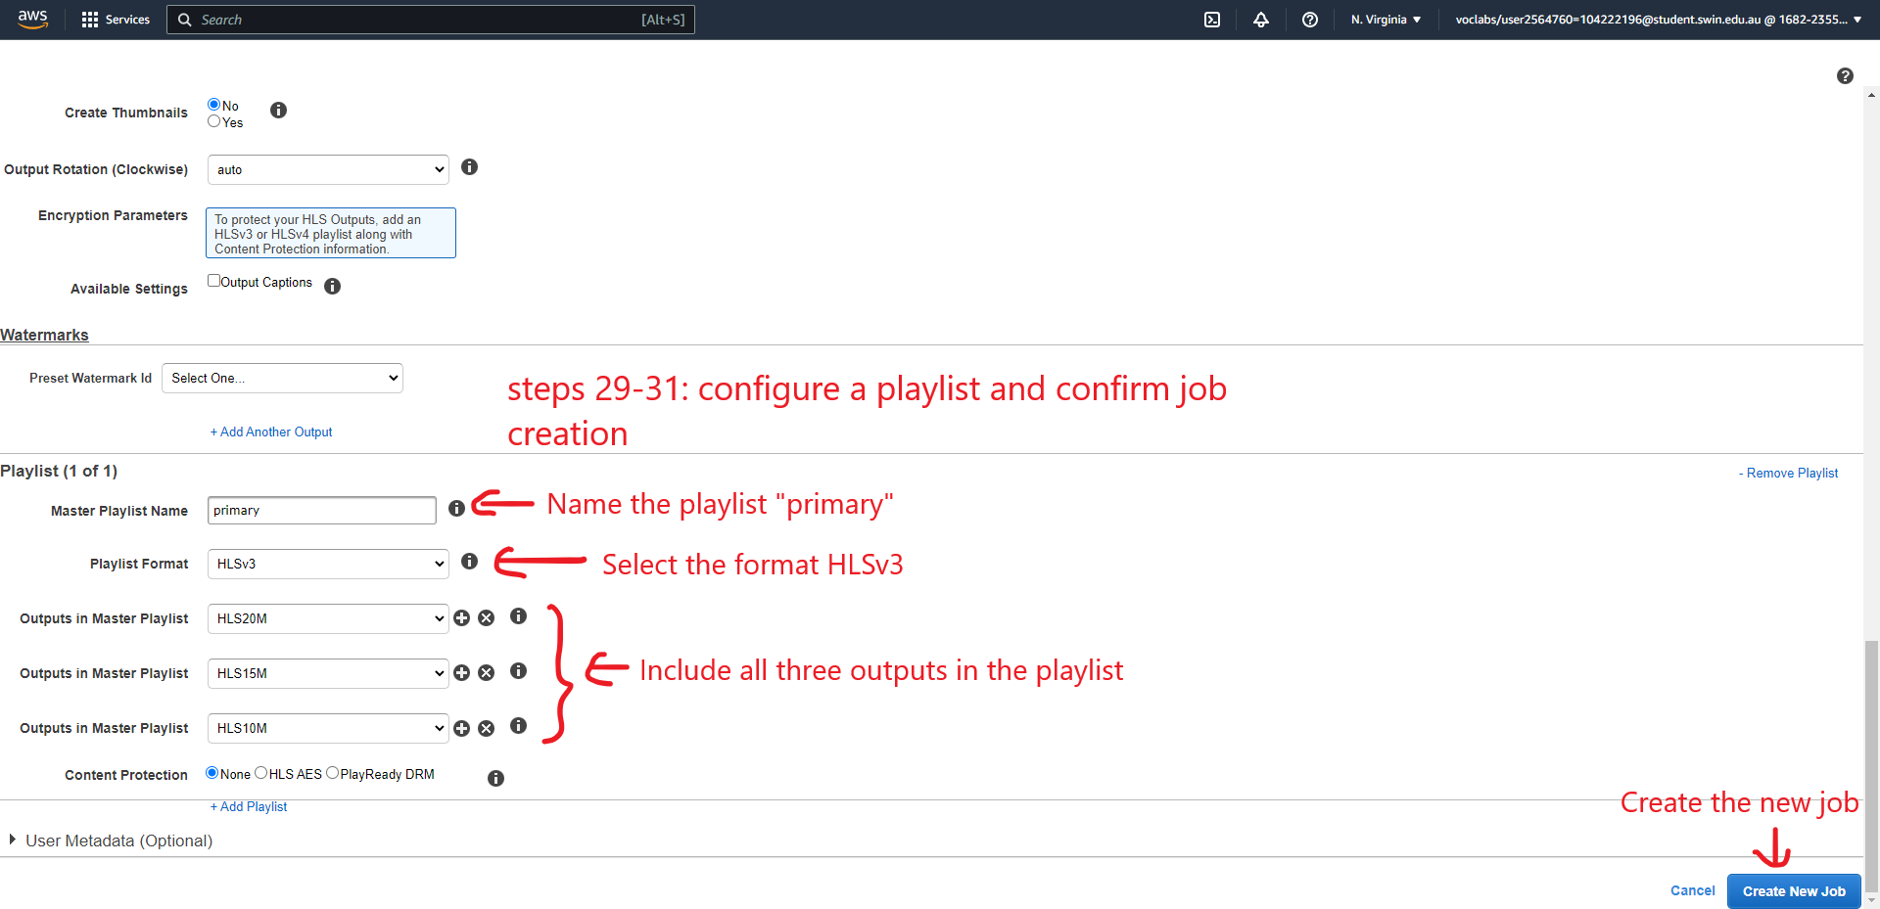

Task 4: Test Playback of the Dynamic (Multi Bit-Rate) Stream (steps 32-43)

